We would like to take this opportunity to introduce ourselves:
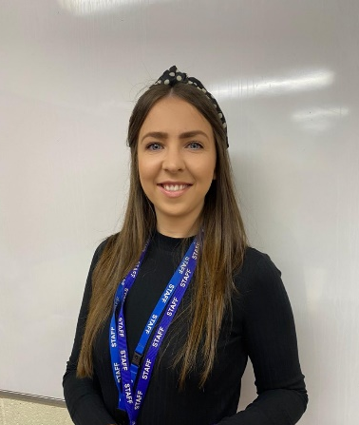
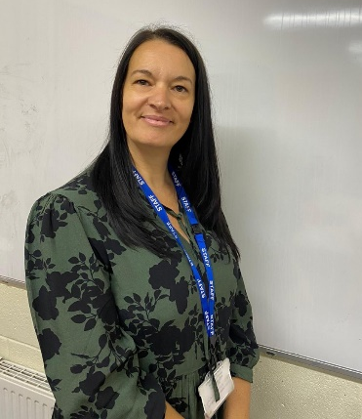

I’m Mrs Akyurek I’m Mrs Kelshaw
(Nursery Teacher) (Nursery Nurse)
Important Notice: Following COVID19 Government guidance, we are unable to allow parents to enter the school building, as we have done in previous years. This is to minimise risk and for the safety of children and staff. On your child’s first day we would ask that you encourage them to enter the building independently, if they become upset an adult will be happy to take your child off you and settle them. We understand this may be difficult for you but please be assured that if your child does not settle after 15 minutes we will give you a call.
To aid transition we would like to invite you to attend school on ***** September @ 1.30pm. You will stay for around 15-20 minutes in the Early Years outdoor area. This is an opportunity for your child to meet the staff and familairise themselves with the space. Unfortunately you will not be permitted to enter the building at this time.
Please note- this is subject to change based on the completion of the building work currently taking place. If we have to cancel, we will contact you to let you know.
If you have any queries please contact Mrs Akyurek using the following email; c.akyurek@northcote.liverpool.sch.uk. Please check the school website for regular updates.

