The Nursery Class

There are two Nursery classes one in the morning and one in the afternoon. They cater for children who have turned three. The Nursery class is staffed by a teacher, a Nursery Nurse and learning support assistant. The Nursery class also has several students throughout the year. We have approximately 50 children attending Nursery in a variety of sessions. Those sessions are listed below.

Morning Nursery- 9.00-11.45am

Afternoon Nursery- 12.30-3.30pm

Limited number of full day places following the government’s 30 hour childcare initiative.
9.00-3.30pm
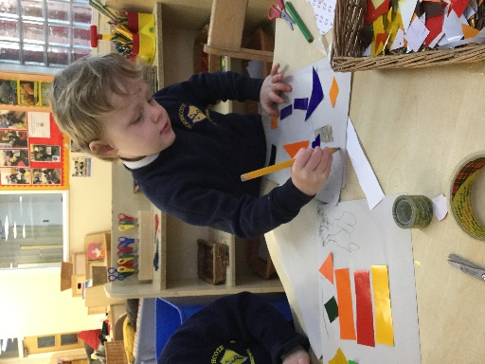
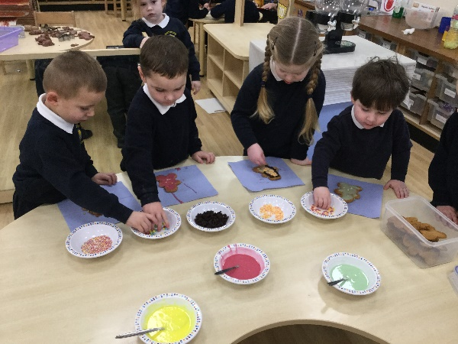
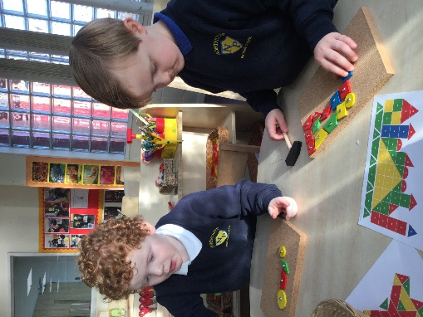

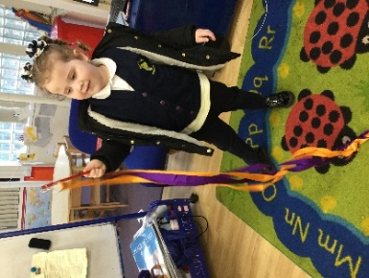
Preparing Your Child For Nursery

Our aim is to help children to become happy, independent learners so we hope you will support us with the following points:

- Children can often be anxious about starting a new school. Pass by and talk about how much fun it will be, visit us on the open day and try on the uniform as many times as your child would like to. Some parents like to buy a special bag to put spare clothes in and leave in Nursery.

- It is important that your child is out of nappies or pull ups and using the toilet by themselves. We ask that every parent leaves a change of clothes in the cloakroom, clearly labelled, in case of accidents.

- Please encourage your child to stop using dummies and bottles by the time they start Nursery. This is recommended by the school nurse.

- If they want to wear wellies in the rain, they need to be able to put their own shoes on and off. These can be kept in the cloakroom. Only Velcro pumps or shoes, no laces please.

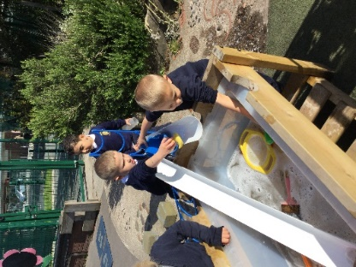
- We encourage children to put their own coats on and to choose their own pegs. (Please ensure all belongings are labelled clearly.) Encourage your child to put on their own coats, hats and gloves independently at home.
Settling into Nursery
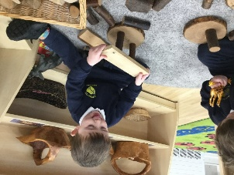
We want to ensure that your child feels safe, secure and happy in our Nursery class right from the very beginning.

We have a staggered intake which means that children start Nursery in small groups. This helps them to settle and get to know the staff and the children. When your child is offered a place in Nursery you will then be invited into school and given a start date.

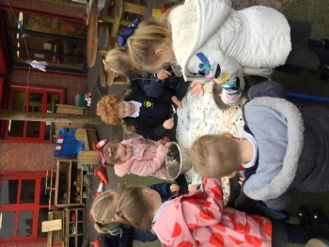
Start dates are allocated by your child’s date of birth/choice of session. This can be moved to a later date if you feel your child is not ready. We can also be flexible over the length of session your child does at first if they need a shorter session to adjust to the change.

The Nursery class has a class teacher who is responsible for all children within the Nursery. However, we also operate a key worker system within our Nursery. Each child will be allocated a member of staff to be their keyworker. This adult will lead sessions with their groups, observe the children and plan next steps.

Useful information about Nursery

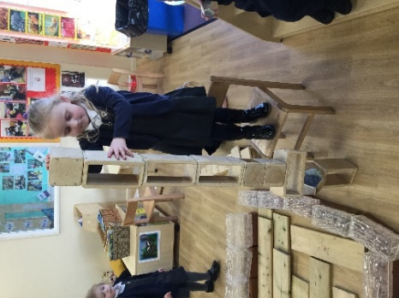
- Nursery children enter through the nursery/ reception playground.
- In the cloakroom, parents can encourage their child to find a pegs, hang their coats up and say goodbye.
- Once children walk through the inner door we ask parents to stay in the cloakroom. The children then go and find their name to self-register.
- We ask for your patience at home time, especially during the first few weeks, as dismissing children can take a while as they get used to the routines and staff become more familiar with who is collecting each child. Please make sure your child is picked up promptly from Nursery to avoid distress. Repeated lateness collecting your child can result in their place being withdrawn.
- We ask that you set a password for your child, this will be used if another person is collecting them at home time. Please let a member of staff know if it is not going to be you picking up.
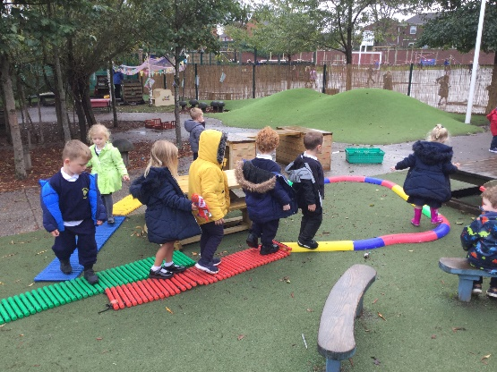
- We encourage families to come in to school and speak to staff if they have any concerns or wish to ask any questions. Usually the best time to do this is after school when the other children have been dismissed.
- We ask families to make a contribution of 50p per week for snacks/baking/making play dough etc. This can be paid each week or several weeks in advance. There is a tick list in the cloakroom.

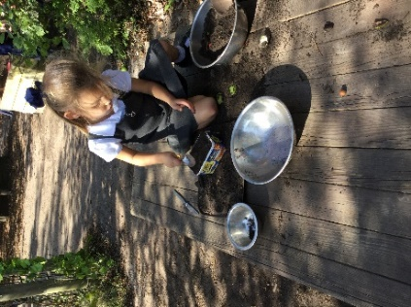
Attendance matters
At Northcote Primary school we expect all families to take their child’s attendance seriously from Nursery all the way through to Year 6. If your child is not in school they are missing out on their education and all of the wonderful activities we have on offer.
- If your child is unwell please telephone school to notify the class teacher. You must also provide a written note when your child returns to school.
- In Nursery- If your child’s attendance falls below an expected level we may withdraw your child’s place and give it to another child on our waiting list.
- Reception to year 6- If your child is five, poor attendance is referred to the education welfare officer and you may be fined.
- We reward 100% attendance in several ways. Each half term children are given certificates and stickers. If your child achieves 100% attendance by the end of the school year, they will receive a special treat too!

Getting Messy
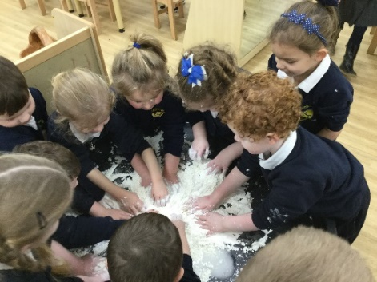
As a normal part of their day in the Foundation Stage, all children have access to paint, glue, felt pens, scissors, sand, water, dough and many more messy resources. Please be prepared for your child to come home with their clothes messy. This is a sign that they have been very busy having fun! This is one of the main reasons why we wear a uniform.

Outdoor learning
At Northcote Primary School we believe that learning outdoors is vital for children and we offer free access to outdoors throughout the day in all weathers. It is a wonderful exciting and stimulating place for children to play and learn.
Children may get wet when they are having fun playing in the outdoor area. Please make sure you provide a spare set of clothes then children can be easily changed when they come back inside.

Reading
We are a ‘Reading for Pleasure’ school. Throughout the whole school we ensure that children are given a variety of opportunities to share lots of new and exciting books. We also encourage children to retell their own stories and then move on to writing them down to share with others.
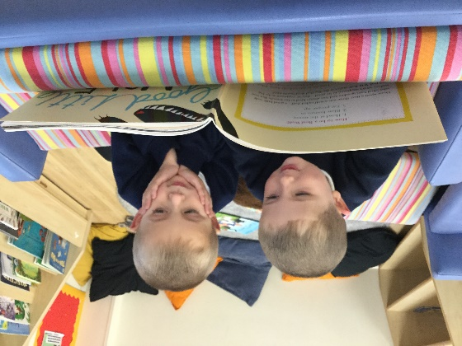
We operate a library system by sending home one book per week for you to enjoy with your child. You can keep a log of all the books you have shared, in your child’s reading record. There are also lots of books available in the cloakroom for you to borrow and return once finished. We encourage families to donate their old books so that other children can enjoy them too.

As children enter Nursery we begin phase one letters and sounds encouraging children to listen and tune into sounds. These are the first steps in your child’s own independent reading journey. We will tell you more about this when your child joins us in Nursery.

Mathematics
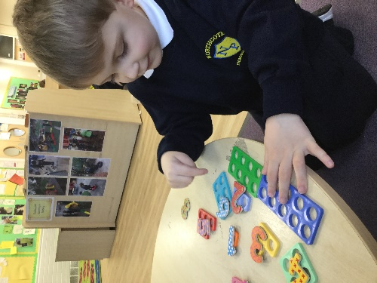
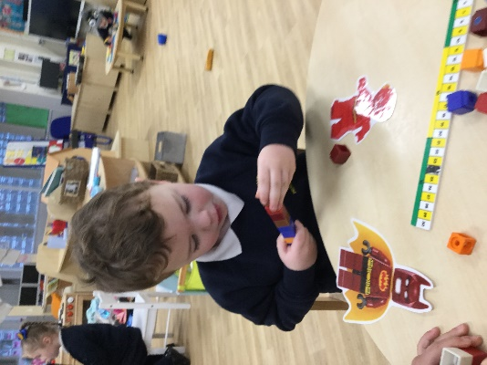
Children have lots of opportunities to take part in variety of maths activities both inside and outside. We seek to develop children’s curiosity and problem solving skills in lots of different ways. One day we might be measuring ourselves to see how we have grown, another day we might be hunting around our school looking for shapes or numbers. We always have lots of fun in Nursery developing our mathematical skills.
We record children’s mathematical development in their learning journeys. Parents are always welcome to come and take a look.

Parental Involvement

At Northcote Primary School parental/carers/family involvement is very important to us. We aim to keep in touch with you in a number of ways.

Come and play sessions
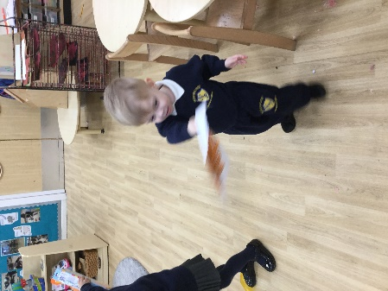
Once per half term family members are encouraged to come and spend some time in Nursery to play with their child and to take part in all of our Foundation stage activities. We will give you notice of the dates and it would be lovely if you could join us.
We also hold puzzle mornings and chatterbox sessions and have a variety of courses that run through the year for families to join in with.

School Newsletter/Website

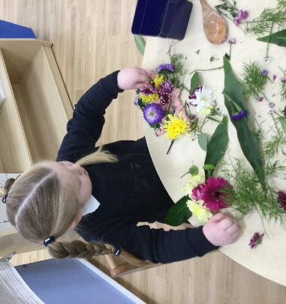
A newsletter is issued regularly to parents. The newsletter contains important information regarding forthcoming events during each term and items of news regarding the life of the school.

We also send out regular Nursery newsletters to inform you of anything happening that is specific to Nursery. These are also displayed in the cloakroom.

Please also see our website and our class page which is updated regularly alongside our school twitter.

Sharing, and contributing to your child’s learning journey

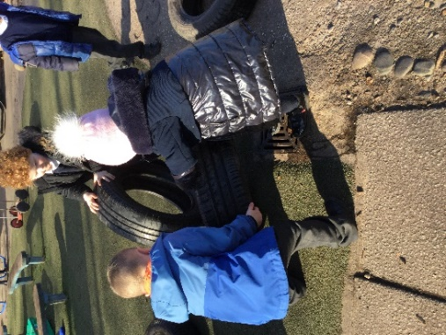
Every child who attends Northcote Early Years Foundation Stage has a Learning Journey which is completed throughout the Early Years Foundation Stage. This is to celebrate your child’s experiences and their unique skills. As your child progresses through the Early Years Foundation Stage, staff make notes and take photographs and add these to the book. At the end of the year you will be able to take it home to keep as a memory of your child’s year in Nursery/ Reception at Northcote Primary School.

We send home WOW slips to complete at various points in the year and there are always some in the cloakroom for you to record your child’s special moments. These are shared with the rest of the children in the class and celebrated.

Everyone at Northcote Primary School looks forward to welcoming you and your child into our school community.

