Summer term Week 6:
Week commencing 1st June 2020

Reading:
Task 1: Reading speed and questioning
Please make sure you continue to read on Reading Plus. It is very useful and fun website that will help you make progress with your reading!
Everyone in the juniors should now have a login for Reading Plus.
Please see the guide some of our Year 6 children made on our Reading Curriculum page if you are struggling to log on.
Reading-Plus-Guide-for-Northcote-Parents
Task 2:
Now that the weather is nice, continue to make sure you are using some time to sit and read in the sunshine.
Continue to vary what you read. You may want to use this challenge from Everton Football club to help you:
http://www.liverpoollearningpartnership.com/reading/everton-in-the-community-reading-bingo/
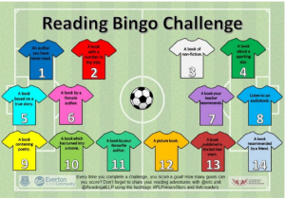
Task 3: Reading for pleasure.
This week, we would like you to try to read an e-book or listen to an audio-book using the links below:
https://www.bbc.co.uk/teach/school-radio/audio-stories/zh3t2sg
https://www.worldbookday.com/storytime-online/
https://stories.audible.com/start-listen
https://www.booktrust.org.uk/books-and-reading/have-some-fun/storybooks-and-games/
https://www.oxfordowl.co.uk/for-home/find-a-book/library-page/ https://www.oliverjeffers.com/books https://www.worldofdavidwalliams.com/elevenses/
- Discuss with somebody in your house how it compares to reading from a physical book yourself. Did you enjoy it? Why/why not?

Last week's work:
Niamh:
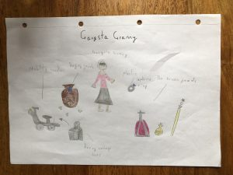

Writing
TASK: Possessive Apostrophes
This week's focus is on using possessive apostrophes.
Watch the video below to recap on how to use possessive apostrophes.
https://www.youtube.com/watch?v=8dY2SE1G900
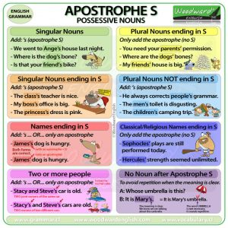
Use the Information poster above to make sure you understand the different rules when using an apostrophe for possession.
Possessive Apostrophe Information
English Task 1
English Task 2
English Task 3
English Task 4
English Task 5
https://www.youtube.com/watch?v=jfVBrpIhH60
English Task 6

Task: Creative writing
Pobble 365 upload a new picture every day. Go on the link for one day this week and write a story about the image you can see. Make sure you tweet or email it to us so we can see what you’ve been doing – it also gives me a chance to enjoy some exciting new stories!
https://www.pobble365.com/
*Don’t forget all of the sentence types we have learnt, to help engage your reader:
Fronted Adverbials, 2A, Double ly, the more, the more, ad same ad, similes, personification etc.
If you have forgotten these, click on this school's link, which has posters for each sentence type:
http://www.kelsall.cheshire.sch.uk/serve_file/94451

Last week's work:
Niamh:
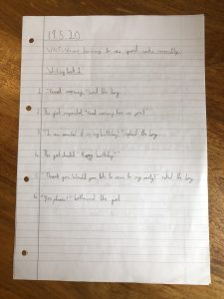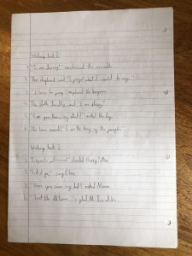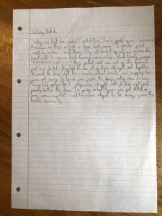
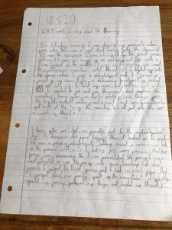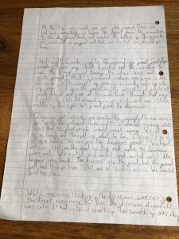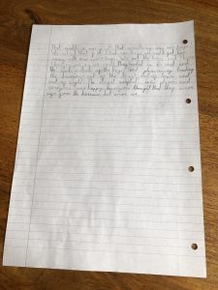

Simon:
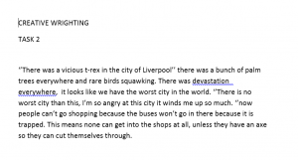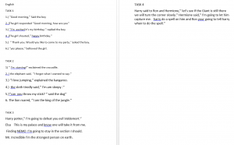

Maths: Angles and Triangles
This week's focus: Angles and Triangles
This week we will be identifying different types of angles. We will also be identifying different types of triangles.
Watch the video below to find out about the different types of angles:
https://www.youtube.com/watch?v=NVuMULQjb3o
Angles Information
Maths Task 1 - Identifying Angles
Maths Task 2 - Ordering Angles
Maths Task 3 - Angles Reasoning and Problem Solving
Triangle Information
Maths Task 4 - Identifying Triangles
Maths Task 5 - Triangles Reasoning and Problem Solving

Last week's work:
Niamh:
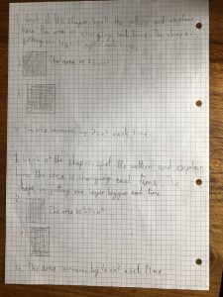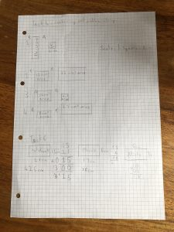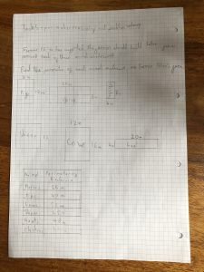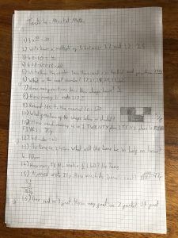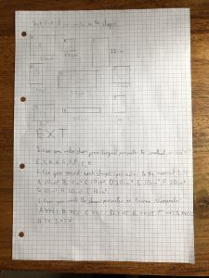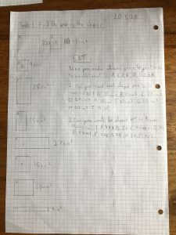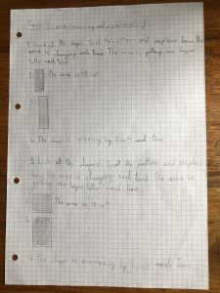

Science: States of Matter
This week's focus: Compare and group materials together, according to whether they are solids, liquids or gases
This term, are new unit is 'States of Matter'. We will be understanding what solids, liquids and gases are and how they change when temperature is changed.
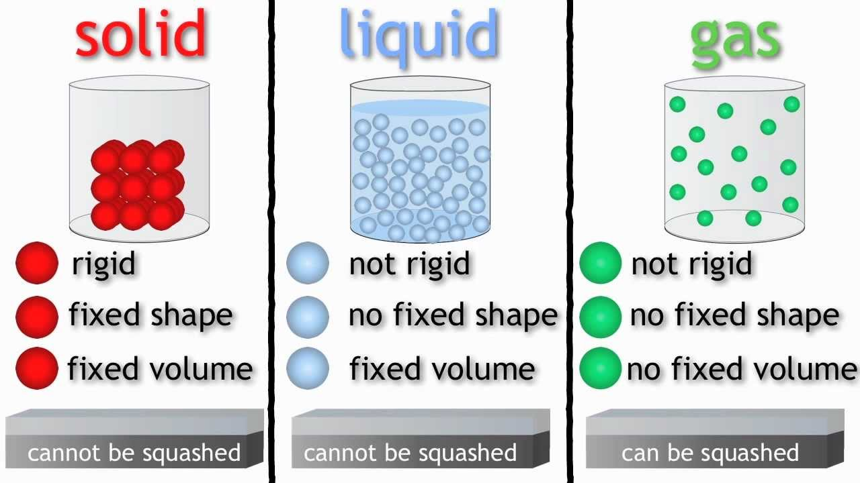
https://www.bbc.co.uk/bitesize/topics/zkgg87h/articles/zsgwwxs
Use the website link above to learn about solids, liquids and gases.
Science Task 1

Last week's work:
Niamh:
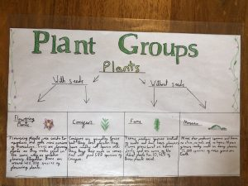

Simon:
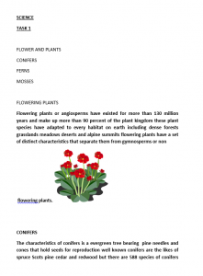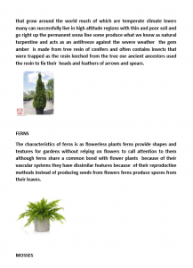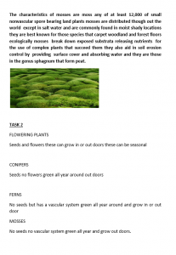

Humanities - History: Anglo Saxons
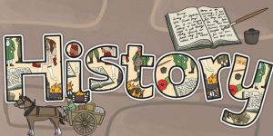
Was Alfred the Great really the greatest?
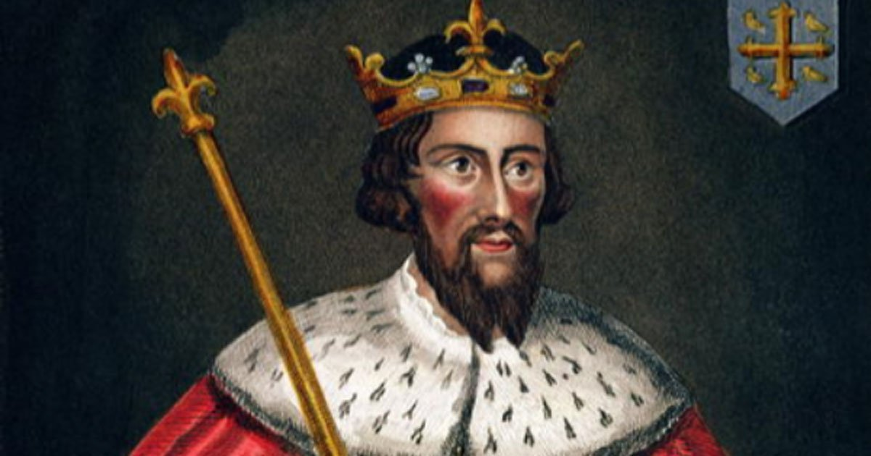
This week you will be learning about two famous Anglo Saxon kings. Alfred the Great, one of the only kings in British history to be called 'Great'. The other king is King Athelstan, the first 'King of all England'.
Task 1 = Research information about Alfred the Great and King Athelstan.
Use the internet link below to research information about Alfred the Great and King Athelstan.
https://www.bbc.co.uk/bitesize/topics/zxsbcdm/articles/z9tdq6f
Task 2 = Consider who was the better King.
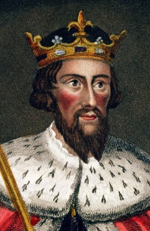
Write a list of positives and negatives for Alfred the Great and King Athelstan.
Identify their strengths as a King by finding evidence from the information provided.
Identify their weaknesses as a King by finding evidence from the information provided. .
Use the table below to record your ideas.
Alfred the Great vs. King Athelstan Table
Task 3 = Create a Top Trump Card
Now that you have compared the two kings. You are now going to create a Top Trump card for each king. You will give each king a score out of hundred based in their skills. You can create your own categories or you can use choose from the listed categories below:
- Bravery
- Intelligence
- Longevity (the time spent as king)
- Influence (how did they influence the nation)
- Positive acts (how many positive acts did they have when they were king)
Top-Trump-Template

Last week's work:
Niamh:
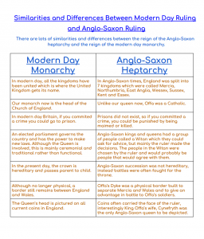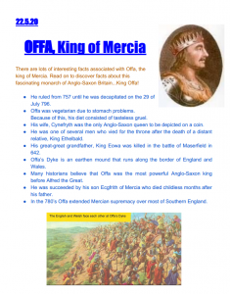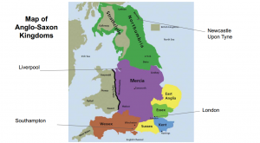

Simon:
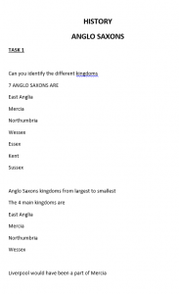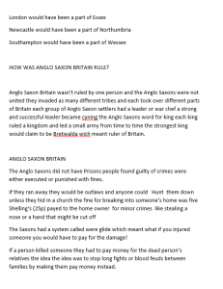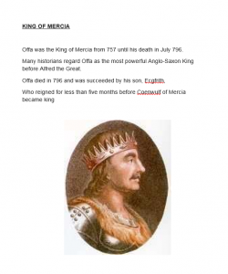

Art: Drawing
This week's focus: Shading
Task = Add shading to a landscape.
We are going to build on our shading skills by adding shading to a landscape.
Watch the video tutorial below. During the tutorial, you will learn how to draw a landscape and how to add in the shading detail. Here you will be able to apply the skills you have practised over the last couple of weeks.
In addition to this, you may be able to build on your sketching and shading ability by creating your own landscape e.g. back garden, park, your view outside your bedroom window etc.
https://www.youtube.com/watch?v=RODzWvaDM7M&feature=emb_rel_pause

Last week's work:
Niamh:
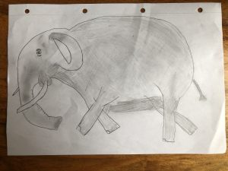

PE
This week's focus: foot-eye-coordination/compare performances against previous ones and demonstrate improvement to achieve their personal best.

Task 1:
In one minute, do as many 'Shuffle takes’ as you can. Record how many you get each day and see if you can improve daily.
I've put a link here if you need help with these:

https://www.youtube.com/watch?v=WbLVKfdSMT0

Task 2:
In one minute, do as many ‘star jumps’ as you can. Record how many you get each day and see if you can improve daily.

Task 3:
Create a fun game that you can play at home during lockdown. You need to use items that are available around the house e.g. toilet roll, rolled up socks, baskets, paper cups etc.
Share videos of your game, including rules, on the school twitter page for other children to watch and play at home.

In addition to the tasks above. Below is an 'Active June' calendar. Each day there is a suggested activity to complete to keep you moving while being at home. I hope you enjoy!

Active June Calendar

Below are some good links to daily exercise videos:

Joe Wicks :https://m.youtube.com/user/thebodycoach1

Oti Mabuse Dance Class: https://m.youtube.com/user/mosetsanagape

Niamh is using maths to track and compare her improvement in the P.E. tasks!
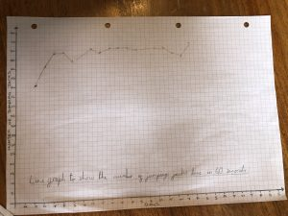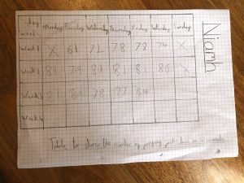

Computing
This week's focus: Build a 3D world
This term, we are focusing on building a 3D world. We will be using Minecraft to create the 3D world. We will become more familiar with using Minecraft and by the end of the unit we will be able to create a Anglo Saxon Minecraft Village.
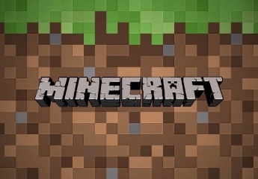
Task 1 = Research about Anglo Saxon villages.
Use the website link below, to research an Anglo Saxon village. Click on the huts to find out who lives in them.
http://www.earlybritishkingdoms.com/kids/saxon_trades.html

In addition to this, conduct your own research by looking at different images and reading different sources of information.
Task 2 = Plan and design your own Anglo Saxon Village.
Using your understanding of Anglo Saxon villages, plan and design your own village. Consider who will need houses and think about the materials that you will need to use.
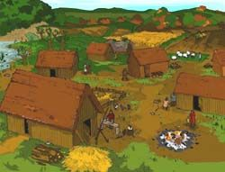
Task 3 = Navigate the world of Minecraft, using keyboard controls.
If you have access to Minecraft, begin to understand how to use the keyboard controls.
If you are unable to access Minecraft, watch the tutorial below.
https://www.youtube.com/watch?v=CemaY8B7f1E

Spanish
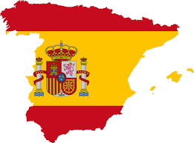
Watch this video from Marina to recap asking and answering personal questions in Spanish:
Video Señorita Marina
Spanish Task 1 and 2
Last Week's Spanish Answers

Last week's work:
Niamh:
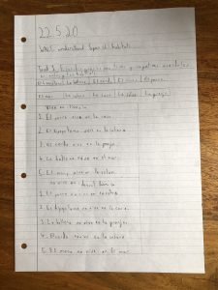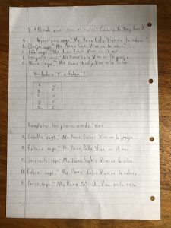

PSHE
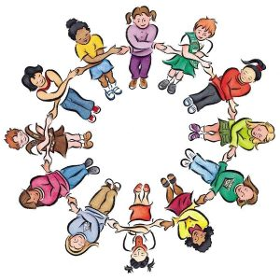
This week's focus: How important do you think it is for people to enjoy their jobs?

There is plenty of time to decide what we might like to do when we grow up. Even when people do decide, they sometimes change their minds! It can be helpful to think about it though! Use the following to help:
• What do you enjoy?
• What are you good at?
• What don’t you enjoy?
• Are there any jobs you think you might like to do?
• Are there any jobs you think you would not like to do?
• Do you have a dream job at the moment?
PSHE Task Sheet
Sometimes we describe some of the things that need doing as jobs e.g. tidying, washing up, being a playground buddy at school.
• Have you ever been asked to do a job at home or at school?
• What was it? Did you enjoy doing it? Sometimes there are jobs that need doing that perhaps we don’t enjoy as much (tidying our bedrooms?!) but it can be good to get into the habit of doing these.
• Create a list of jobs you could complete at home and at school.
• Ask someone at home or school if you can do the jobs. Tick them off once they are done!

Last week's work:
Niamh:
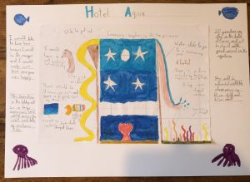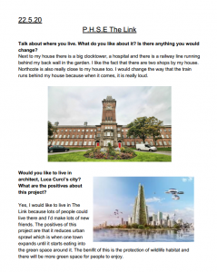

Religious Education

NATRE (The National Association of Religious Education) have organised a competition that can be completed at home. The competition is based on Spirited Arts and Spirited Poetry and is still open!

Take a look at the PPT below to find out more about the competition and to see some fantastic examples! Here is another piece of work that has been produced already by one of our pupils to give you some inspiration!
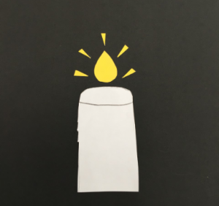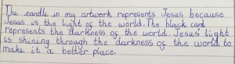
Spirited Arts and Poetry 2020 PPT
Judging will take place in August and there will be £20 Amazon vouchers for the winning entries!

We can’t wait to see your entries! Remember to tweet them to @NorthcoteSch or email them to S.mcmurtry@northcote.liverpool.sch.uk. Good luck!

Music
Click on the link below to find your weekly Music activity. Watch the Ten Pieces film and complete the creative activity described on the website.
https://www.bbc.co.uk/teach/ten-pieces/ten-pieces-at-home/zjy3382

What else have Class 9 been up to?
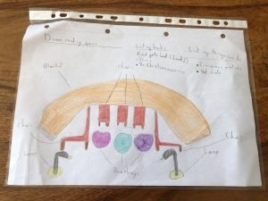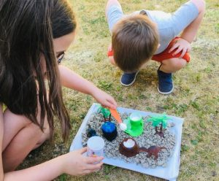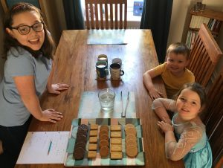
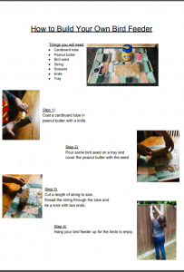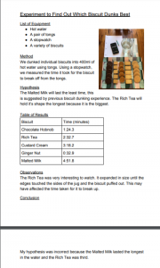
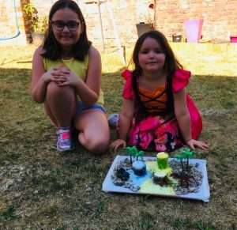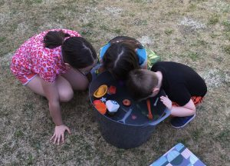
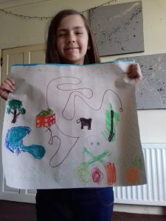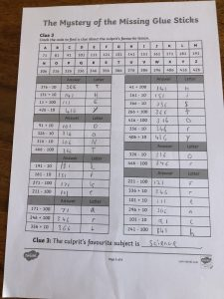
Super PowerPoint! - Puppies and Bunnies - by Emily

Estelle has been producing some beautiful artwork for her new baby brother!
