Summer Term 2, Week 4:
Week commencing 22nd June 2020

PE: Northcote ‘Sports Month’ Fitness Challenge
During this time of the year, we should have been competing in our ‘Sports Day’. Rather than cancelling, we have decided to change our plans this year. Instead of a ‘Sports Day’ we are organising a ‘Sports Month’.
For the next 4 weeks, we will be setting daily fitness challenges for you and your family to complete – this will help us achieve the recommended 30 minutes of exercise each day!
Each day you need to check the school’s Twitter account to see what the daily fitness challenge is.
https://twitter.com/northcotesch?lang=en

We want to see as many photos of you and your family completing all the fitness challenges as well as images of fitness record cards. (Remember when posting a photo on Twitter do not include your name).

If you are able to complete all of the week’s challenges, you will receive a certificate.

To be able to receive the certificate, you need to email an image of the fitness record card completed weekly to your class teacher.

Good luck and let’s get fit!
Sports Month Fitness Challenge Record Chart

Reading:
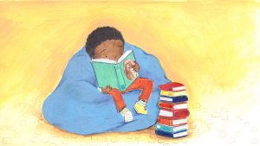

Task 1: Reading speed and questioning
Please make sure you continue to read on Reading Plus. It is very useful and fun website that will help you make progress with your reading!
Everyone in the juniors should now have a login for Reading Plus.
Please see the guide some of our Year 6 children made on our Reading Curriculum page if you are struggling to log on.
Reading-Plus-Guide-for-Northcote-Parents

Task 2: Vocabulary – NEW TASK!
Reading and exploring words you don’t know is a great way to develop the vocabulary that you can use in everyday conversation and your writing.
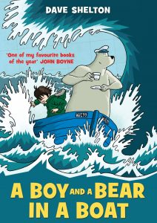
- Read the extract from The Boy and a Bear in a Boat by Dave Shelton using the link below:
A Boy and a Bear in a Boat extract (with permission from www.lovereading4schools.co.uk)
- Remember to read it carefully, using your phonics skills to sound out words you don’t know.

Now, let’s explore the meaning of some of the words by making an 'Alphabet word organiser!'
- Draw a grid with 25 squares to print off the template below
- Use the template below to list any words that you find when reading that you don’t know the meaning of.
- Predict what you think the word might mean.
- Now, use a dictionary, the internet or speak to an adult to find the meaning of these words.
- Ask another member of your household to test you on the meaning of one of the words each day.
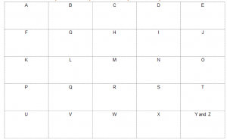
S2, W4 - Reading Vocabulary Task - Alphabet word organiser
EXT: Try to use these words in conversation or your writing this week

Task 3: Reading for pleasure
Take a look at https://summerreadingchallenge.org.uk to join and take part in the Reading Agency’s Summer Reading Challenge:
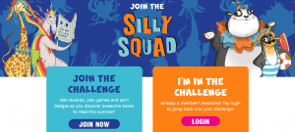

Writing
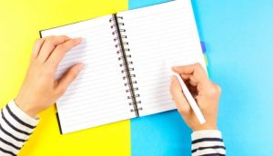
Task 1: Creative Writing
As part of your English task this week, I would like you to use the extract from our reading vocabulary task (The Boy and a Bear in a Boat). Look at how the extract ends. Use your imagination to write the next part of the story! What do you think happens next? Remember, there is no right or wrong answer, just enjoy seeing where the story takes you!
*Don’t forget all of the sentence types we have learnt, to help engage your reader:
Fronted Adverbials, 2A, Double ly, the more, the more, ad same ad, similes, personification etc.
If you have forgotten these, click on this school's link, which has posters for each sentence type:
http://www.kelsall.cheshire.sch.uk/serve_file/94451

Task 2: Writing a letter
We have been off school for a long, long, LOOOONNGGGGG time now. We have missed out on so much interaction with one another, and I am sure you are all missing one another as much as I am missing you all. You also might not have seen members of your family that you would usually see. I would like you to take this time to reach out to someone by writing them a letter. Your letter might tell them all the things you have been doing over the last few months. You might ask them what they have been doing (hopefully they will reply!) You might want to draw them a picture or simply just say hi!

Task 3: G.P.S
It is very important that you continue to work on your grammar, punctuation and spelling! This week, I would like you to complete the G.P.S booklet on 'Determiners'.
Click here for your booklet: S2, W4 - G.P.S Determiners

Maths: Revision of Place Value and Number
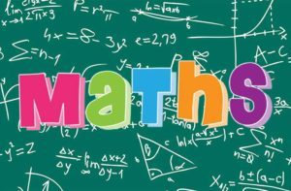

TASK 1: Place Value and Number
During the course of this week, I would like you to work through this booklet which will recap all the things we have looked at in year 4 about place value and number. Understanding place value is SO important and will help you in all areas of maths, which is why we ALWAYS need to consolidate our learning in this area!
Click here for your maths booklet: S2, W4 - Maths Place Value and Number activity booklet

TASK 2: Mental Maths
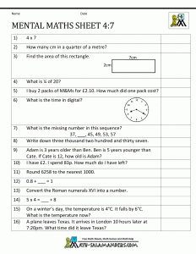

Click here for the mental maths worksheet: S2, W4 - Mental maths

TASK 3: Times tables speed and questioning
Make sure you keep up your times table recall by logging in daily to your TT Rockstars. Hit the button is also excellent for times tables and easy to download as an app on your phone or tablet.

Science: States of Matter
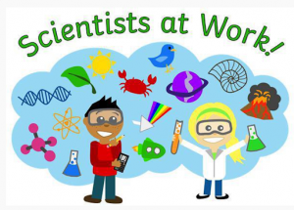

This week's focus: observe that some materials change state when they are heated or cooled
This term, our new unit is 'States of Matter'. We will be understanding what solids, liquids and gases are and how they change when temperature is changed.
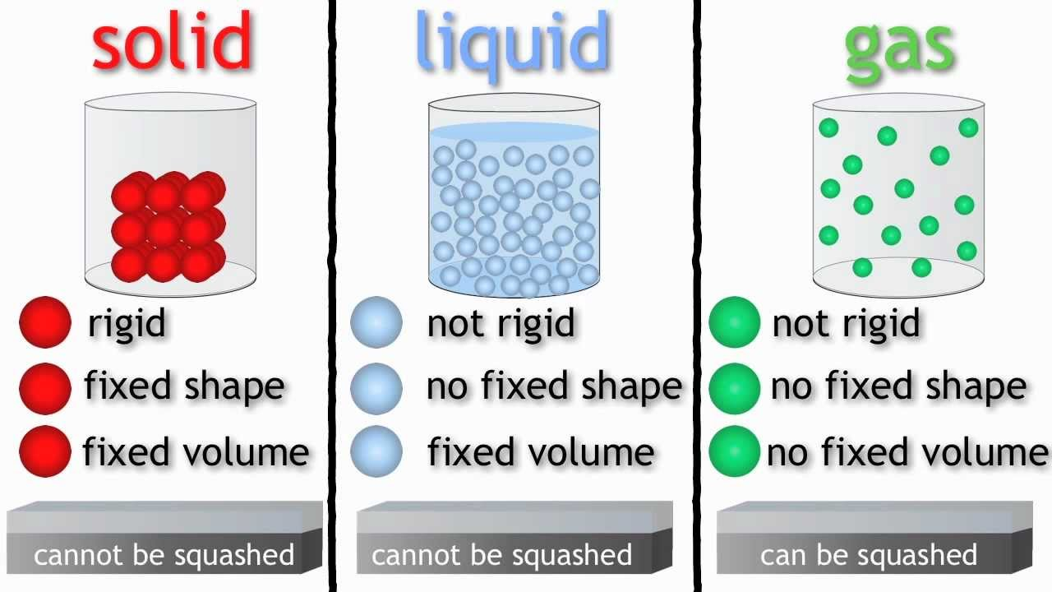
Science Experiment
Science Results - Read After Experiment

Humanities - Geography: Mapping Skills
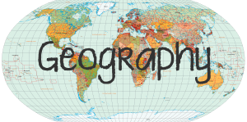

We have now finished our History topic and are moving onto our final Geography topic - we are going to be learning about maps!

What is a map?
A map is a two-dimensional drawing of an area.
Maps can show the countryside, a town, a country or even the whole world.
They are used to help plan routes from one place to another, or to find certain features such as castles or hills.
Different types of map are used for different things depending on whether you are walking, driving or even flying somewhere.
Maps can be on paper or on a mobile phone, tablet or computer.

How to use a map
The top of most maps is north and a compass can be used to find which direction north is. Compasses show four directions - north, east, south and west.
The needle always points north, so when that is lined up with the map it is easy to see in which direction things are.
Maps are not drawn to the same size as the ground because they would be far too big! Instead they are drawn to a smaller scale.
The scale on a map is a set of numbers that can be used to compare distances and can be written, for example, as 1:25,000.
This means that the actual size of the ground is 25,000 times bigger than it is on the map.
The same scale can also be written as 4cm to 1km, so every four centimetres on the map is one kilometre in real life.
Watch the video on the BBC website below:
https://www.bbc.co.uk/bitesize/topics/zvsfr82/articles/zdk46v4#:~:text=A%20map%20is%20a%20two,such%20as%20castles%20or%20hills.

Map reading
To be able to understand maps, it is important to have map-reading skills.
Maps are usually too small to contain lots of writing so instead there are symbols which show important landmarks, places and areas.
There is usually a key at the side of the map which explains what these symbols mean.
Your task:
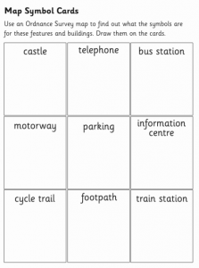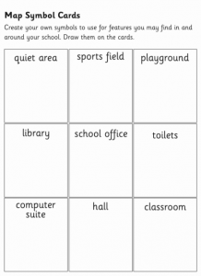
S2, W4 - Geography map symbols

Art: Drawing
This week's focus: Creative drawing
Task: Create an optical illusion with one vanishing point.
Optical illusions are pictures drawn specifically to trick the brain into thinking that it is seeing what it is not, or at least is not possible.
Watch the video tutorial below. During the tutorial, you will learn how create an optical illusion with one vanishing point.

https://www.youtube.com/watch?v=9DW4wg2DdwU

Computing

YOUR TASK: Pic Collage
While you are at home, you will have plenty of time to spend on your devices (hopefully doing your work!) This week, I would like you to create a ‘Pic Collage’ about one (or more) of the topics from this week's work. For example, you might want to make a Pic Collage about an inspirational figure for your R.E. task; you might want to create on about World Music Day for your Music task and so on. The choice is yours! I would like your Pic Collage to include both information and pictures. You can practise changing the background, font, colour and cropping photos which you have screen shot. Pic Collage is a free app so you should be able to download this to your device free of charge. Happy Pic Collaging!

Spanish
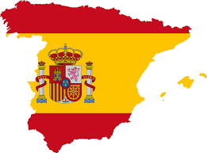
Now that we have finished our Animals in their Habitats unit, we are going to recap over the different topics we have learnt this year, to ensure we are fluent and confident in different areas of Spanish!
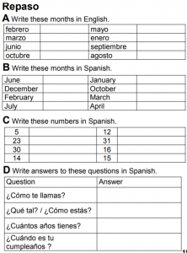
Click here for your worksheet: S2, W4 - Spanish Revision

PSHE
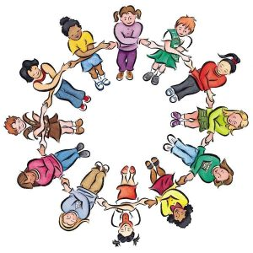

Story: Following a three-month closure period, Chester Zoo and many other zoos have been allowed to reopen.
Question: Should zoos have been allowed to reopen earlier?

Task 1: Read the Picture News article below and then complete the question sheet to share your thoughts.
Picture News at Home – 22nd June
Picture News Prompt 2 – 22nd June

Task 2: Expressing you opinion about zoos
Read the opinions in the blue speech bubbles with somebody at home. Discuss the questions in the orange bubble with an adult to help you express your own opinions about zoos.
Resource 2 – 22nd June

Task 3: Finding animals that belong to different groups
Animals are divided into two main groups: vertebrates (have a backbone), invertebrates (do not have a backbone). Vertebrate are divided into:
- Fish
- Mammals
- Birds
- Reptiles
- Amphibians.
Can you find examples of animals that would fit these 5 categories?

Religious Education: Inspirational People
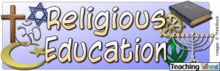

Inspirational People
Inspirational people make a positive difference to the lives of others. There are inspirational people all around us; in your home, your classroom, your sports club, your library, your local shop,etc.

TASK 1: What makes an inspirational person/hero?
- Listen to ‘Special Kind of Hero’ using this link:
https://www.youtube.com/watch?v=meGptWZWgUA
- As you listen, follow along with the lyrics below and underline any words or phrases that tell you the qualities of an inspirational person
Special Kind of Hero Lyrics

TASK 2: Research an inspirational person
- 5 facts about them
- Why do people think consider them to be inspirational?
- What is one thing you can learn from them?

Below is a list of people who are widely considered to be inspirational. Choose somebody from the list below (or somebody of your choice!) and research them:
- Nelson Mandela
- Mahatma Ghandi
- Mother Teresa
- Colonel Tom Moore
- Jesus
- Guru Nanak

TASK 3: Create a poster including facts about how they have made a positive difference to the lives of others. You may wish to draw a picture of them and present information around it. (Feel free to do a Pic Collage!)

Music
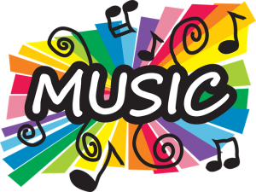
Click on the link below to find your weekly Music activity. Watch the Ten Pieces film and complete the creative activity described on the website.
https://www.bbc.co.uk/teach/ten-pieces/ten-pieces-at-home/zjy3382

Sunday 21st June 2020 was WORLD MUSIC DAY!
Can you find out...
- What World Music Day is
- The history of World Music Day
- The benefits of listening to music

