Summer Term 2, Week 2:
W.C. 8th June 2020

Reading:
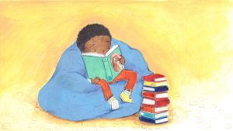
Task 1: Reading speed and questioning
Please make sure you continue to read on Reading Plus. It is very useful and fun website that will help you make progress with your reading!
Everyone in the juniors should now have a login for Reading Plus.
Please see the guide some of our Year 6 children made on our Reading Curriculum page if you are struggling to log on.
Reading-Plus-Guide-for-Northcote-Parents

Task 2:
Now that the weather is nice, continue to make sure you are using some time to sit and read in the sunshine.
Continue to vary what you read. You may want to use this challenge from Everton Football club to help you:
http://www.liverpoollearningpartnership.com/reading/everton-in-the-community-reading-bingo/
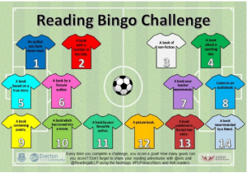

Take a look at https://summerreadingchallenge.org.uk to find out more about the Reading Agency’s Summer Reading Challenge which is starting very soon!:

Task 3: Reading for pleasure.
Think about your favourite book or story that you have read. What did you like about it? Fill in the book review template all about your favourite book!
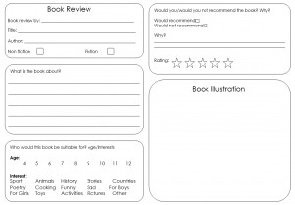
Click here to download your book review template

Writing
Task 1: Writing a fable
This week, I would like you to show off your creativity and all the writing skills you have acquired this year by writing your own fable! What is a fable? A fable is a story that will feature plants, animals or natural forces that are given human qualities. Fables will also always end with a certain 'moral' that the writer will want to put across to the reader. This moral will be the lesson that the writer wants the reader to learn as they read the fable in front of them. One of the most famous fables is The Hare and the Tortoise.

Part 1: Click the link below which takes you to the BBC website. Choose a couple of fables to listen to. When you listen to the fables, write down:
a) Who the characters are
b) What events/problems occur in the story
c) What the moral of the story is
https://www.bbc.co.uk/teach/school-radio/english-ks1--ks2-aesops-fables-index/z73s6v4

Part 2:
You are going to make up a fable of your own! Follow these steps:
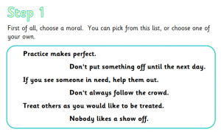
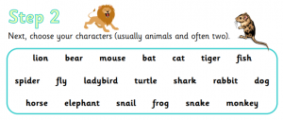
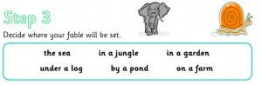
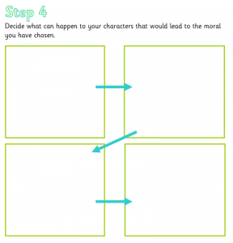
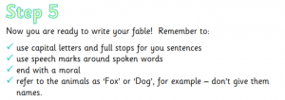

Click here to see all of the 5 steps to creating a fable

You are now going to plan your own fable! Here is an example plan to help you:
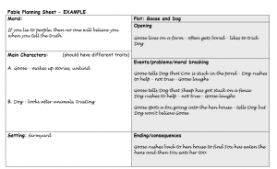
Click here for your worksheet - Planning your fable (an example is included)
I cannot wait to read your finished fables next week! Send them to me: l.toby@northcote.liverpool.sch.uk

Task 2: Creative writing
Pobble 365 upload a new picture every day. Go on the link for one day this week and write a story about the image you can see. Make sure you tweet or email it to us so we can see what you’ve been doing – it also gives me a chance to enjoy some exciting new stories!
https://www.pobble365.com/
*Don’t forget all of the sentence types we have learnt, to help engage your reader:
Fronted Adverbials, 2A, Double ly, the more, the more, ad same ad, similes, personification etc.
If you have forgotten these, click on this school's link, which has posters for each sentence type:
http://www.kelsall.cheshire.sch.uk/serve_file/94451

Task 3: G.P.S.
It is really important that you continue to practise your grammar, punctuation and spelling to ensure your writing is of the highest quality! Click on the document to complete a practise G.P.S. test and send me them to mark! l.toby@northcote.liverpool.sch.uk
Click here for your G.P.S. Practise Test

Maths: Statistics
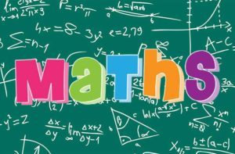

This week's focus: Statistics - pictograms, bar charts and line graphs.
This week, we will be learning about statistics! We will be looking at the importance of data and the different ways it can be presented, depending on the type and scale of information we have. Specifically, we will be looking at pictograms, bar charts and line graphs.
Task 1:
Read through the PowerPoint to learn about each different way of presenting data. For each one, you will be able to complete a worksheet at your chosen level (mild, medium or hot) and I have also included some problem solving and reasoning extensions!
Part 1 - Pictogram worksheet
Part 2 - Bar chart worksheet
Part 3 - Line graph worksheet
(The tasks are all included in the PowerPoint).
PPT - Maths - Statistics - Pictograms, bar charts and line graphs
PDF - Maths - Statistics - Pictograms, bar charts and line graphs

Task 2: Mental Maths
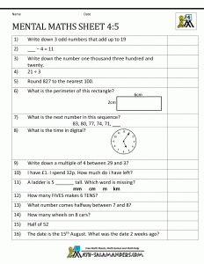
Click here for a print out of the mental maths worksheet

Task 3: Times tables speed and questioning
Make sure you keep up your times table recall by logging in daily to your TT Rockstars. Hit the button is also excellent for times tables and easy to download as an app on your phone or tablet.

Science: States of Matter
This week's focus: Understand properties of particles.
This term, our new unit is 'States of Matter'. We will be understanding what solids, liquids and gases are and how they change when temperature is changed.
This week we will be conducting an experiment understanding the properties of particles in liquids.
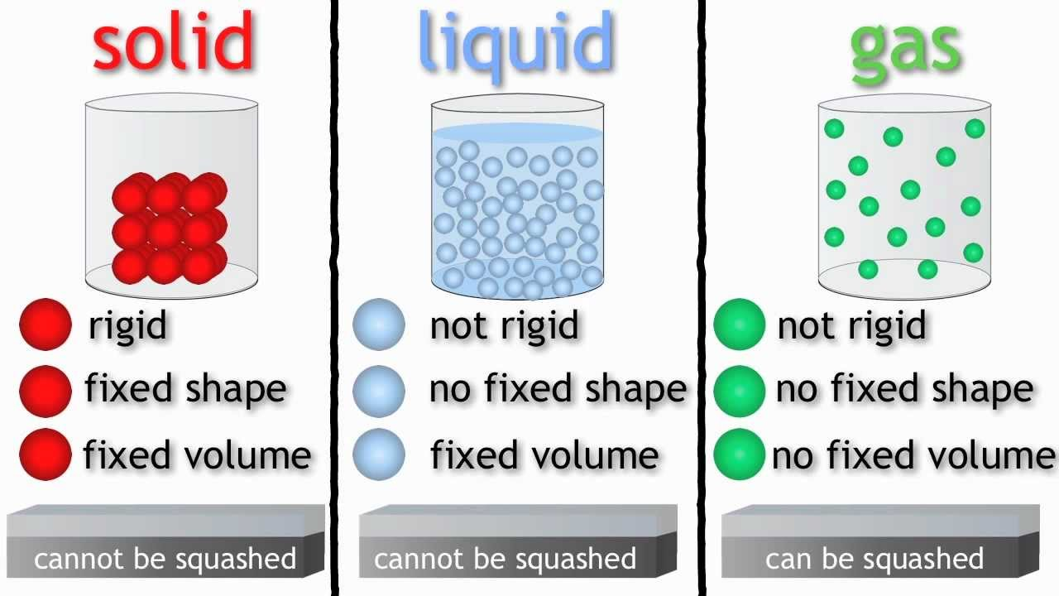
https://www.bbc.co.uk/bitesize/topics/zkgg87h/articles/zsgwwxs
Use the website link above to recap about solids, liquids and gases.
Science Task - Experiment

Humanities - History: Anglo Saxons
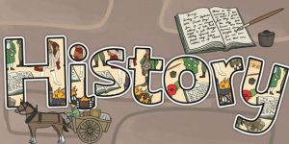

During the Summer term, you have been learning all about the Anglo-Saxons. You have covered: who they were, where they came from and when; their religion including different gods and goddesses; the type of food they ate and their farming methods; leisure and entertainment; the different kingdoms, how they ruled as well as the effectiveness of different king's leaderships.
Now, it's time to put everything you have learned to the test... it's POP task time!
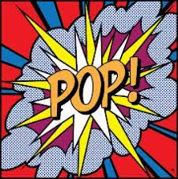
TASK: Create a historical test/quiz using your knowledge about the Anglo-Saxons.
It is your turn to become the teacher. When writing the questions for your quiz/test, think, what would I want to ask you to ensure you had learned lots about the Anglo-Saxons? Try to create as many questions as you can and then test somebody at home to see if they know the answers! Have you got what it takes to become a quiz master?
Don't forget to email me your quizzes to see if I can get the answers correct! l.toby@northcote.liverpool.sch.uk

Art: Creative Drawing
This week's focus: Creative drawing
Task: Create a 3D optical illusion of a hand.
Optical illusions are pictures drawn specifically to trick the brain into thinking that it is seeing what it is not, or at least is not possible
Watch the video tutorial below. During the tutorial, you will learn how to draw your hand as a 3D optical illusion.

CHALLENGE Task: Create a 3D optical illusion of a hand with colour.
If you want to challenge yourself, you can watch the clip below and add colour to your 3D hand!

PE
This week's focus: foot-eye-coordination/compare performances against previous ones and demonstrate improvement to achieve their personal best.

Task 1:
In one minute, do as many 'Shuffle takes’ as you can. Record how many you get each day and see if you can improve daily.
I've put a link here if you need help with these:

Task 2:
In one minute, do as many ‘star jumps’ as you can. Record how many you get each day and see if you can improve daily.

Task 3:
Create a fun game that you can play at home during lockdown. You need to use items that are available around the house e.g. toilet roll, rolled up socks, baskets, paper cups etc. Share videos of your game, including rules, on the school twitter page for other children to watch and play at home.

In addition to the tasks above. Below is an 'Active June' calendar. Each day there is a suggested activity to complete to keep you moving while being at home. I hope you enjoy!
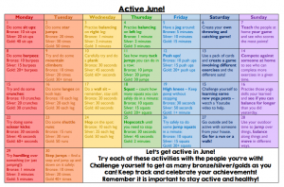
Active June Calendar

Other resources to keep active:
- Joe Wickes has been doing a session every day to help keep our bodies healthy while we are at home: https://www.youtube.com/playlist?list=PLyCLoPd4VxBuHn84_as427AwkVpahrqti
- Alternatively, Oti Mabuse is doing daily dance classes. The lessons focus on fun movements that everyone can master!: https://www.youtube.com/user/mosetsanagape/videos
- If you need to stretch or relax, try some yoga!: https://www.youtube.com/user/CosmicKidsYoga

Computing
This week's focus: Continue to build your 3D world
This term, we are focusing on building a 3D world. We will be using Minecraft to create the 3D world. We will become more familiar with using Minecraft and by the end of the unit we will be able to create a Anglo-Saxon Minecraft Village.
Last week, you should have researched information about Anglo-Saxon villages which would have enabled you to plan and design your own Anglo-Saxon village. You may have even had a chance to play around with Minecraft and began to understand how to use the different keyboard controls.

Task: This week, I want you to begin creating your Anglo-Saxon Minecraft village. Watch the detailed YouTube video below to help and inspire you!

Spanish
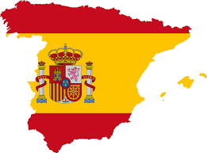
Watch this video from Marina to recap asking and answering personal questions in Spanish:
Video Señorita Marina
Task 1:
Read and recognise familiar words using knowledge of the phoneme 'j'.
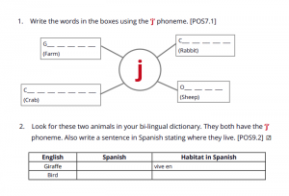
Task 2:
Read and recognise familiar words using knowledge of the phonemes 'll' and 'ce'.
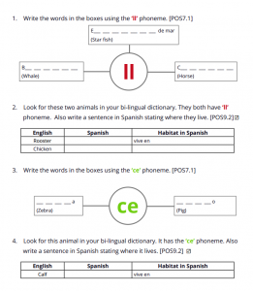

Click here for a print out of the Spanish Tasks

PSHE
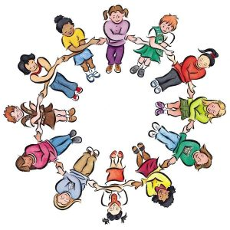
Story: As some children return to school, we think about how our routines have changed during this time.
Question: How important is it to have a routine?

Task 1: Read the Picture News article below and then complete the question sheet to share your thoughts.
Picture News at Home – 8th June
Picture News Prompt 2 – 8th June

Task 2: Create a list of some of the things you do in a typical day. For each of these, draw a picture then cut it out. Use them to help organise part or all of your day. You may want to use the template below to help you:
Routines Template
I would love to hear about your routines at home! Don’t forget to tweet your work to @NorthcoteSch or email it to l.toby@northcote.liverpool.sch.uk

Religious Education - The Good Samaritan

Watch the animation on this link
https://www.bbc.co.uk/bitesize/clips/z4vcd2p

This story is a parable. Parables were stories with a hidden meaning that Jesus told to make a point. The end of the story shows Jesus explaining the meaning of the story. Read it below.

What do you think?’ Jesus asked. ‘Which of the three was a neighbour to the man attacked by robbers?’
‘The one who treated him kindly,’ the man replied. Jesus said, ‘Go and do the same.’
Based on Luke Chapter 10, verses 30-33

Task:
Answer the following two questions.
- Why do you think Jesus told this story?
- One reason Jesus told this story was to teach people how to behave. How might people have been behaving for Jesus to need to tell this story?

Music
Task 1: Click on the link below to find your weekly Music activity. Watch the Ten Pieces film and complete the creative activity described on the website.
https://www.bbc.co.uk/teach/ten-pieces/ten-pieces-at-home/zjy3382

Task 2: Answer the questions below.
- Who is your favourite singer/group? Why?
- What is your favourite genre of music? Why?
- What is your favourite song at the minute? Why?

