Missing Digits! Challenge 1.
Can you help me find the missing digits?

Challenge 1
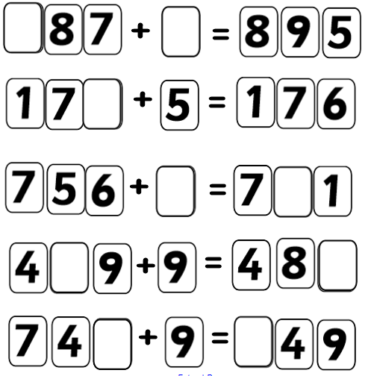

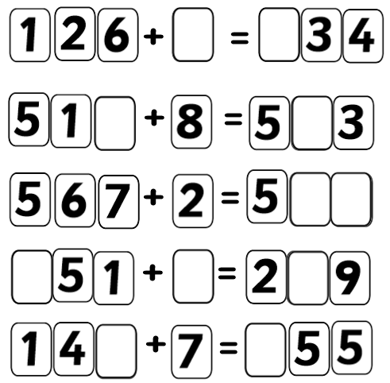

Missing Digits! Challenge 2.
Can you help me find the missing digits?

Challenge2
