Summer term Week 2: Week commencing 27th April 2020

Reading:
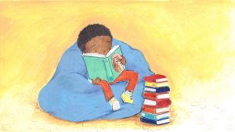
Everyone in the juniors should now have a login for Reading Plus. Please see the guide some of our Year 6 children have made if you are struggling to log on. Please email me if you do not know your reading plus login: l.toby@northcote.liverpool.sch.uk
Reading-Plus-Guide-for-Northcote-Parents
Task 1: Reading speed and questioning: Make sure you are reading daily on your Reading Plus.
Now that the weather is nice, make sure you are using some time to sit and read in sunshine. Although we cannot go out to different places, reading is able to transport us to wherever our imagination takes us.
Task 2: Reading for pleasure: Whilst you are having more time to read books at home, you may have started to consider genres of books that you particularly like or do not like. This week, I would like you to write a book review for a book you have/have not enjoyed. Use a template from the link below to help you write your response: http://www.primaryresources.co.uk/english/pdfs/bookEY.pdf

Writing
Thank you to those year 4s who have sent their letters telling us what they have been up to, it has been lovely to hear from you. Keep emailing or tweeting the letters and we will respond.
Task 1: Stories from other cultures: In class, we would now begin to look at stories from other cultures. During this topic, we watch the Disney film 'Coco', which some of you may have already seen. The story follows a 12-year-old boy named Miguel who is accidentally transported to the Land of the Dead, where he seeks the help of his deceased musician great-great-grandfather to return him to his family among the living and to reverse his family's ban on music.
The clip below has been taken from the film. Your task is to watch the video and write a first person recount of what happens to you. Remember, YOU are Miguel. During this scene, consider: what Miguel does, how he feels, what he can see? Hear? Smell? Touch? Remember to use all the descriptive writing skills we have looked at this year. Use the WILF below to help you with your writing.
WILF (What I’m Looking For)
Examples/Explanations
Fronted adverbials: Use these at the start of your sentences to give more information. E.g;
- One sunny day,
- Later that afternoon,
- As I was running,
- When the moon was bright,
2A sentences: 2 adjectives come before the noun;
- The white, fluffy cat
- The beautiful, talented dancer
Metaphors/Similes: Use these to compare objects/people to things they are not;
- She was as fast as a racing car.
- The snow was a blanket on the grass.
Doubly 'ly' openers: Use 2 'ly' words, with commas, to start your sentence;
- Carefully, slowly, I opened the wooden, ancient door.
- Cautiously, vigilantly, I peered through the transparent, crystal-clear glass window.

https://www.youtube.com/watch?v=G8KXArIA0nQ

Task 2: Creative writing:
Alison Wilcocks, the author of the descriptosaurus, has set us our very own task for this week:
Task: Can you use this sentence starter to create an opening paragraph? (5 sentences minimum. Think about brackets, dashes, commas, semi-colons). I have put some openers to help you.

The town was a warren of tunnels, narrow and twisting alleys and a maze of dark, tall buildings. Up above… From behind… In the distance… The smell of…

Think about:
- What else can you see?
- In front, behind, above, to the left, to the right, in the distance.
- What can you hear?
- What can you smell?
- What can you touch?
- Can you taste anything?
- What time of day is it? Is it light, dark, misty, foggy?
- What is the weather like?
- Who is there?
- Why are they there?
- Are they in danger? Why? From what?
- What happens next?

*Don’t forget all of the sentence types we have learnt, to help engage your reader:
2A, Double ly, the more, the more, if....then, ad same ad etc.

If you have forgotten these, click on this school's link, which has posters for each sentence type:
http://www.kelsall.cheshire.sch.uk/serve_file/94451

Examples from week 1:
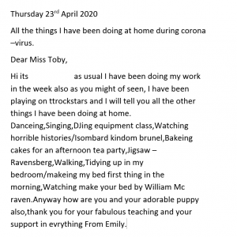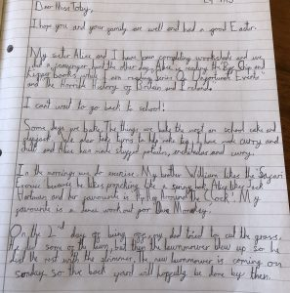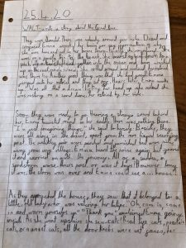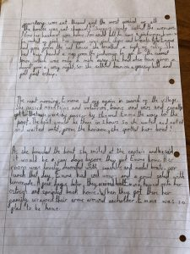

Maths: subtraction
Normally, each half term starts with revising our four operations.
This week, our focus is: subtraction
Task 1:
Choose the band of questions you feel comfortable answering. You may try a mix of them all!
Band 1 | Band 2 | Band 3
1) 184 - 31  2) 293 - 181  3) 472 - 58  4) 194 - 88  5) 264 - 178  6) 1087 – 299  7) 3654 - 2984 | 1) 1984 - 864  2) 8465 - 6954  3) 4684 - 798  4) 4571 – 1451  5) 6212 - 799  6) 12899 – 1562  7) 5471 - 1547 | 1) 12.4 – 3.1  2) 15.16 – 4.07  3) 16.23 – 12.98  4) 84.32 – 18.76  5) 78.94 – 52.66  6) 123.12 – 77.33

Reasoning:
- Is it always, sometimes or never true that you need to exchange when using column subtraction. Explain your answer and give examples to prove that you are correct.

Task 2: Mental Maths
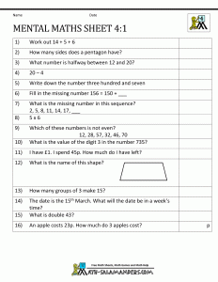

ANSWERS from last week:
Task 1:
- £6.37 + £2.54 = £8.91
- £5.76 + £3.18 = £8.94
- £4.23 + £5.45 = £9.68
- £6.43 + £3.28 = £9.71
- £3.49 + £3.27 = £6.76
- £5.38 + £4.48 = £9.86
- £6.47 + £2.49 = £8.96
- £4.35 + £3.47 = £7.82
Task 3:
Miss Toby buys a loaf of bread for £1.15, a carton of orange juice for £0.79, a bar of chocolate for £1.75, a candle for £8.97 and a DVD for £9.64. How much money does she spend altogether? £22.30
CHALLENGE:
£1.66 + £10.68 = £12.34 £1.77 + £10.57 = £12.34 £1.88 + £10.46 = £12.34
£1.99 + £10.35 = £12.34 £1.67 + £10.67 = £12.34 £1.68 + £10.66 = £12.34
£1.69 + £10.65 = £12.34 £1.78 + £10.56 = £12.34 £1.79 + £10.55 = £12.34
These are examples, other correct answers are possible. Check addition adds up to £12.34.

Example from week 1:
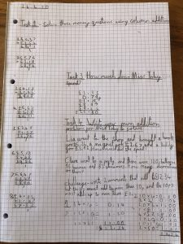

Science: LIVING THINGS IN THEIR HABITATS

Local living things - What are they?

TASK: Using your daily walk, can you investigate your local habitat and record any of the living things that you can find?
- Remember to observe plants as well as animals!
- Consider the habitats of the animals and plants.
- Have they always lived there?
- Has the habitat always looked like this?
- How does the habitat change during different seasons?
Gather a sample of leaves and take lots of photos of the animals and plants that you find and tweet or email them to me: l.toby@northcote.liverpool.sch.uk

Example from week 1:
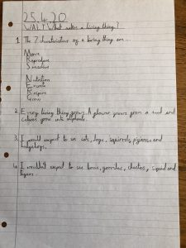

Humanities - History: Anglo Saxons
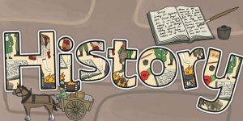

Anglo-Saxon Gods and Goddesses
Read the PowerPoint to find out all about the Anglo-Saxon Gods and Goddesses --> Anglo-Saxon Gods and Goddesses
TASK:
Choose a God/Goddess and create a fact card.
You could include:
- Their name and the day of the week named after them
- What they are the god/goddess of
- Their symbol
- Their special animal
- A picture of them

Example from week 1:
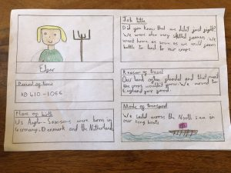

Art: Drawing

TASK: Expressing your emotions through art.
Linked to your PSHE work, I would like you to draw/paint/collage/colour, however you would like, a piece of artwork that expresses an emotion. For example, you may choose happiness and draw things that make you happy, using colours that you think are happy such as yellow. You might want to express a piece of artwork on anger, in which you may draw things that make you angry and use colours such as red. I cannot wait to see how these pieces of art turn out! Tweet them or send to my email: l.toby@northcote.liverpool.sch.uk

A beautiful piece of art from week 1:
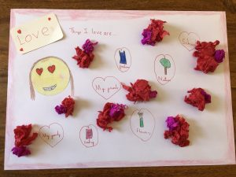

PE
Task 1: Keeping healthy: Joe Wickes has been doing a session every day to help keep our bodies healthy while we are at home. Make sure you’re up early and logged on to his page if you want to join in live. He also has other workouts on there if you miss the live stream: https://www.youtube.com/channel/UCAxW1XT0iEJo0TYlRfn6rYQ
For all you dancers out there, dancer Oti Mabuse holds live dance sessions on YouTube at 11.30: https://www.youtube.com/user/mosetsanagape/videos
For all your footballers out there, Rising Stars also have free lunchtime football skills classes three times a week (Mon, Wed and Fri at 1pm), all you need is a football! https://www.youtube.com/channel/UCJvv0t_SvDgMqWenq_02lVw

Task 2: Compare performances with previous ones and demonstrate improvement to achieve your personal best.
Objective: foot-eye-coordination. Task: In one minute, do as many 'sole taps' as you can. Record how many you get each day and see if you can improve daily. https://www.youtube.com/watch?v=ch604q9xMFU or https://www.youtube.com/watch?v=15y7MGYKuN8

Computing: E-safety

Cyberbullying
Mobile, internet and wireless technologies have increased the pace of communication and brought benefits to users worldwide, but their popularity provides increasing opportunities for misuse, one of which is cyberbullying. It is crucial that children and young people, who are particularly skillful at adopting new technologies, are able to use the internet and mobile phones safely and positively, be aware of the consequences of misuse and how to report any incidents of bullying.
TASK: Create an information poster about what cyberbullying is and how to deal with it.

Spanish
This week's focus: Habitats
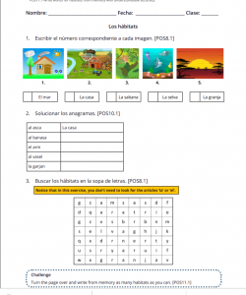

PSHE
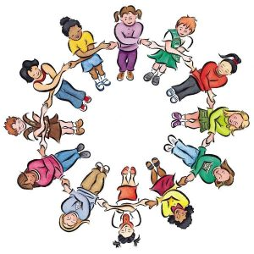
According to Google Maps, travel has decreased by around 85% around the UK.
Do you think people will travel less in the future?
Task 1: Think of some of the ways we make journeys e.g. walk, bike, car, train, aeroplane, boat, space rocket.
- List the ways you have travelled before.
- Are there any you haven’t done but would like to?
- Which is or do you think will be your favourite way to travel? Why?
Task 2: Imagine you are going on a journey. You can travel anywhere you want! Think about:
- Where will you go?
- How will you travel there?
- Who will you go with?
- How long will it take?
- What will the journey be like?
- Use pictures, words or sentences to share your journey.

Here is a video about Earth Day 2020. It’s the 50th anniversary of Earth Day and this video looks at the differences we can make to help our planet.
https://www.youtube.com/watch?v=pHNDeXkADzY&feature=youtu.be
Task 1: Create a poster persuading the people of Liverpool to help our earth by picking up some points from the video. For example: use less plastic, cycle to school or take the bus. Make them as colourful as possible. We’re looking forward to seeing your creations.

