Summer term Week 1: Week commencing 20th April 2020

Reading:
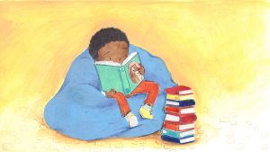
Everyone in the juniors should now have a login for Reading Plus. Please see the guide some of our Year 6 children have made if you are struggling to log on.
Reading-Plus-Guide-for-Northcote-Parents
Task 1: Reading speed and questioning: Make sure you are reading daily on your Reading Plus.
Now that the weather is nice, make sure you are using some time to sit and read in sunshine. Although we cannot go out to different places, reading is able to transport us to wherever our imagination takes us.
Task 2: Reading for pleasure: This week, we’d like you to draw a new front cover for the book you have been reading.

Writing
All of your teachers are looking forward to hearing all about the lovely things you have been doing at home. We’ve seen from our Twitter page that people have baked, been creative, been reading, been dancing and we’re sure you each have your own news to tell.
Task 1: Letter writing: Why don’t you write us a letter to tell us how you’ve been spending your time at home? If you don’t have a stamp, tweet or email it to us! Remember - my email address is: l.toby@northcote.liverpool.sch.uk - I would love to write back!
Task 2: Creative writing: Pobble 365 upload a new picture every day. Go on the link for one day this week and write a story about the image you can see. Make sure you tweet or email it to us so we can see what you’ve been doing – it also gives your teacher chance to enjoy some exciting new stories!
https://www.pobble365.com/
*Don’t forget all of the sentence types we have learnt, to help engage your reader:
2A, Double ly, the more, the more, if....then, ad same ad etc.

If you have forgotten these, click on this school's link, which has posters for each sentence type:
http://www.kelsall.cheshire.sch.uk/serve_file/94451

Maths: addition
Normally, each half term starts with revising our four operations.
This week, our focus is: addition.
Task 1: Solve these money questions using column addition:
- £6.37 + £2.54 =
- £5.76 + £3.18 =
- £4.23 + £5.45 =
- £6.43 + £3.28 =
- £3.49 + £3.27 =
- £5.38 + £4.48 =
- £6.47 + £2.49 =
- £4.35 + £3.47 =
Task 2: Imagine you have been given £10 to spend at Sainsbury's. Go on to their website and look at different items you would like to buy. You must buy at least 3 items. Challenge - can you spend exactly £10?
Task 3: Miss Toby buys a loaf of bread for £1.15, a carton of orange juice for £0.79, a bar of chocolate for £1.75, a candle for £8.97 and a DVD for £9.64. How much money does she spend altogether?
Task 4: Write your own addition word problems for me to solve. Send them to: l.toby@northcote.liverpool.sch.uk
CHALLENGE: Write 2 amounts that add to exactly £12.34. BUT the 1ps must add to more than 10p and the 10ps must add to more than £1.

ANSWERS: To be posted online with next week’s learning.

Science: LIVING THINGS IN THEIR HABITATS

What makes a living thing?

Read the PowerPoint to find out what makes a living thing! --> What makes a living thing?

TASK: Using what you have learnt, create a poster all about MRS NERG! Make sure the poster is bright and informative! You can send them to me, I would love to see them: l.toby@northcote.liverpool.sch.uk

Now, reflecting upon your learning, can you...
- Understand the 7 characteristics of a living thing.
- Explain one of the characteristics in more detail to someone else.
- Discuss which living things you would expect to find in your local environment.
- Consider which living things you would definitely not find locally and why.

Humanities - History: Anglo Saxons
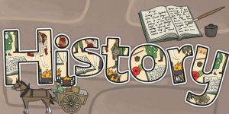

WALT: understand who the Anglo-Saxons were, where they came from and when they first settled.

Read the PowerPoint to find out all about the Anglo-Saxons --> Lesson 1 - Anglo-Saxon who, where, when

TASK:
Create an information passport for the Anglo-Saxon Warrior.
Use your imagination from what you have learned and include:
- Name
- Where they were born
- How they travelled
- What their job title was
- A picture of an Anglo-Saxon
- A small description of why they came to England.

Art: Drawing

TASK: Expressing your emotions through art.
Linked to your PSHE work, I would like you to draw/paint/collage/colour, however you would like, a piece of artwork that expresses an emotion. For example, you may choose happiness and draw things that make you happy, using colours that you think are happy such as yellow. You might want to express a piece of artwork on anger, in which you may draw things that make you angry and use colours such as red. I cannot wait to see how these pieces of art turn out! Tweet them or send to my email: l.toby@northcote.liverpool.sch.uk

PE
Task 1: Keeping healthy: Joe Wickes has been doing a session every day to help keep our bodies healthy while we are at home. Make sure you’re up early and logged on to his page if you want to join in live. He also has other workouts on there if you miss the live stream: https://www.youtube.com/channel/UCAxW1XT0iEJo0TYlRfn6rYQ
For all you dancers out there, dancer Oti Mabuse holds live dance sessions on YouTube at 11.30: https://www.youtube.com/user/mosetsanagape/videos
For all your footballers out there, Rising Stars also have free lunchtime football skills classes three times a week (Mon, Wed and Fri at 1pm), all you need is a football! https://www.youtube.com/channel/UCJvv0t_SvDgMqWenq_02lVw

Task 2: Compare performances with previous ones and demonstrate improvement to achieve your personal best.
Hand-eye co-ordination; Individual: How many times can you throw up a ball in the air and catch it using the same hand? Try this once using your right hand and once using your left hand. Do this each day and see by the end of the week how much you can improve your score!
Hand-eye co-ordination; Group: How long can you throw the ball to another person without the ball dropping? CHALLENGE: Can you play this game with only one hand?

Computing: E-safety

Whilst you are at home, you will be using the internet a lot more to complete your work. However, there are a lot of dangers when using the internet and we have already talked lots in school about how to keep safe and be smart online.
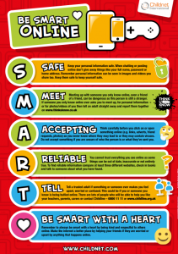
TASK: Create a poster about how to keep safe online.

Spanish
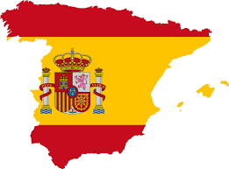
Visit the BBC website to recap the learning we have been doing in Spanish. This week's focus: Numbers
https://www.bbc.co.uk/bitesize/subjects/zxsvr82
PowerPoint: Spanish - Numbers 1-20

TASK:
Write the Spanish numbers.

one ___________________________ five ___________________________

eight __________________________ eleven __________________________

sixteen ________________________ twenty __________________________

Write the English numbers.

catorce ________________________ nueve ____________________________

diecisiete ______________________ trece ____________________________

tres __________________________ cuatro ____________________________

PSHE
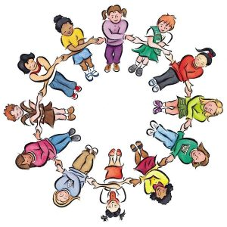
Now, more than ever, it is important that we look after ourselves, our family, our friends and our community.
This week's focus: mental health and wellbeing.
Read through the PSHE association PowerPoint all about expressing feelings --> Mental Health - Expressing feelings
TASK: Create a poster all about the importance of expressing our feelings and keeping safe. During these uncertain times, think about the ways that we can look after our mental health. For example, talking to friends and family, eating healthy, sleeping well, exercising our body and our mind etc. Make your poster lovely and bright and tweet them or send them to me: l.toby@northcote.liverpool.sch.uk

