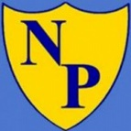 Northcote Primary School Writing Long Term Plan – Year R
This yearly overview gives a coverage guide of genres
Changes will be made to ensure children are understanding learning and being challenged, as well as allowing teachers to match genres to other curriculum areas. Reading is woven into learning throughout.
Following Little Wandle for phonics- please see progression map. Writing opportunities in every lesson.

- Writing own name and VC/CVC words
- Writing labels (Linked to fiction and non-fiction texts)
- Writing letters i.e. to Santa
- Writing sentences linked to own experiences, fiction and non-fiction texts.
- Writing acrostic poems.

