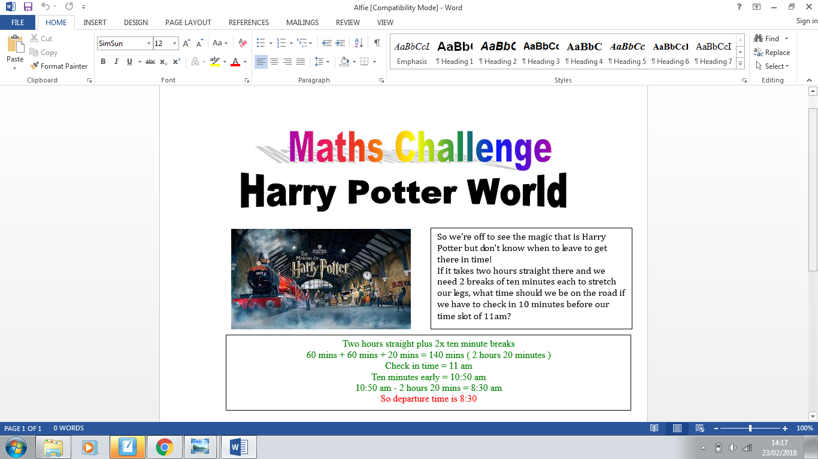

How much?!!!



Each Butter Beer is £4.95

There are 4 people but 2 are prepared to share a beer.

How much change will there be from £20?

So we need 3 Butter Beers

3 x £4.95 = £14.85

£20 - £14.85 = £5.15

So our change is £5.15